Step3:
To protect sensitive information, no database password are coded in the source code. And a template file .env.example is provided to show the required name of variables, and .env is listed in .gitignore to prevent the real secrets is committed to Github.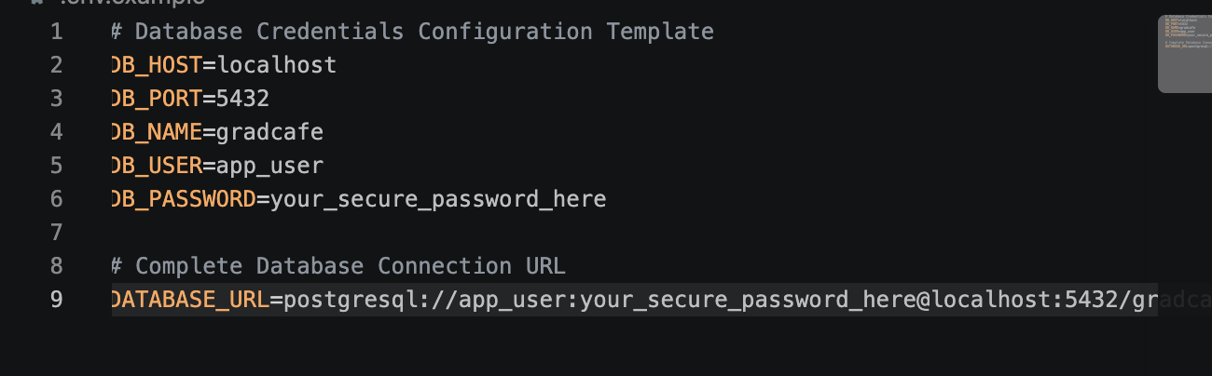
Instead of using the postgres superuser account, I created a limited database user called app_user using following commands: 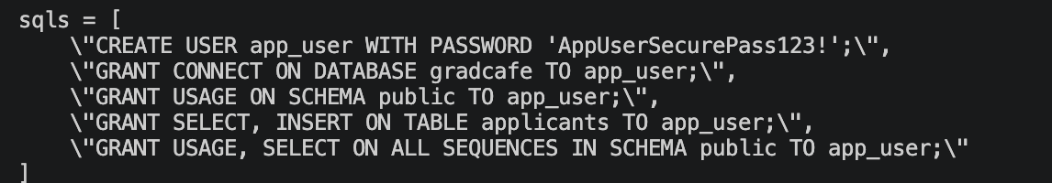
The reason why I gave these rights is:
- Select: because they need to achieve the data from database so application can read and display data
- Insert: app need it because users can add new applicant records via the application
- Sequence: PostgreSQL need this right to generate automatic ID number for new records.
Besides, I did not give administrative privileges or permissions like DROP or ALTER. This ensures even the app is compromised, the attacker cannot delete my data from database or change the schema.
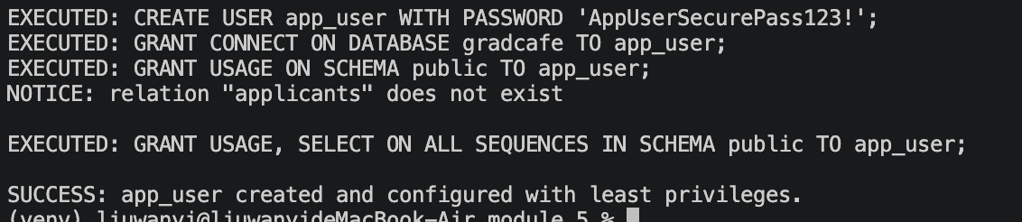

Step4:
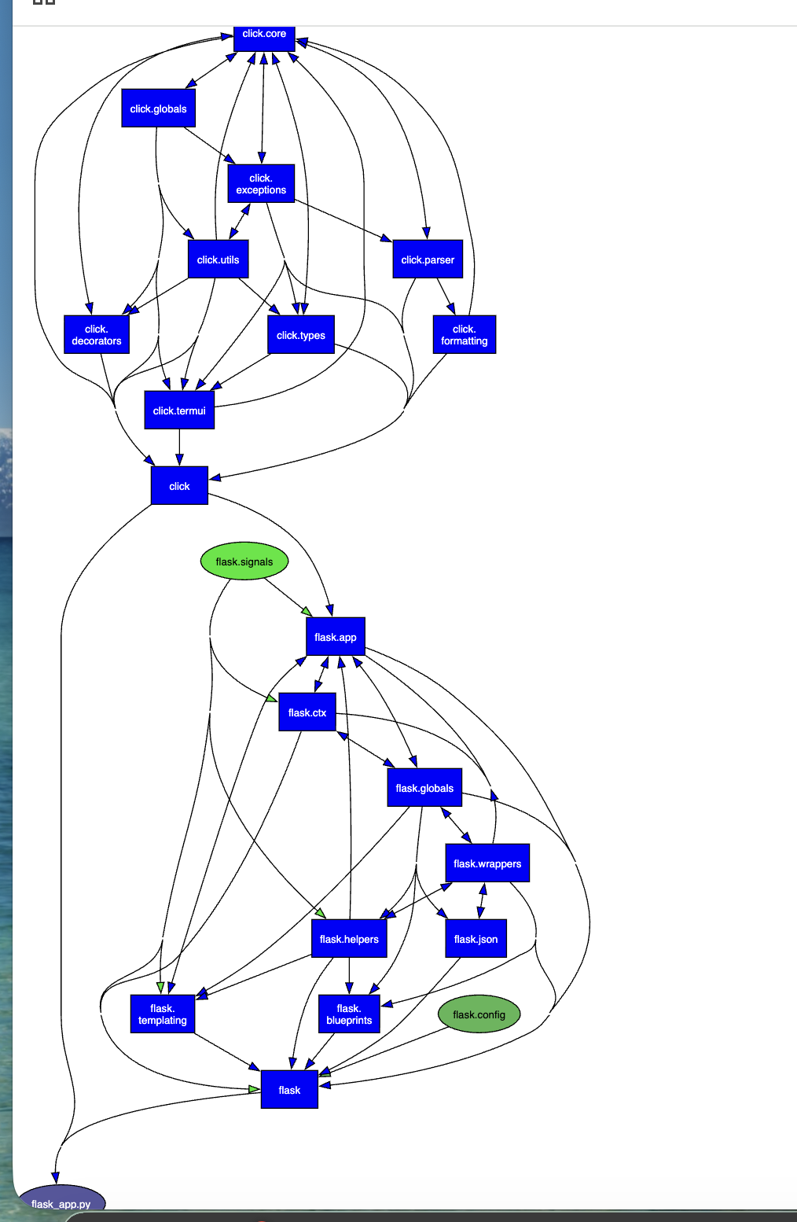
I generated this dependency graph using pydeps to vidualize how flask_app.py interact with external libraries.
At the bottom of the graph, flask_app.py is the main entry point for the whole application, It directly imports the framework of Flask, and this framework is responsible for handling web routs and HTTP request. Those blue and green nodes in the middle is Flask submodules, such as request contexts, helpers and json formatters. Besides, there is a click package on the top of the graph, Flask relies on it to run command-line interface tools.
Step5:
Adding a setup.py file transforms our messy repository into a standard, installable Python package. By running pip install -e ., project module can become globally recognized and it can fix path import errors across tests and scripts. This can eliminate the “works on my machine” issue, guaranteeing consistent behavior for anyone running the project.

Step6:
I executed synk test to perform a security scan on open-source dependencies. The scan identified 2 low-severity issues and 0 critical, high, or medium vulnerabilities detected. These low-severity finding do not pose immediate security threats, so it confirms the overall safety.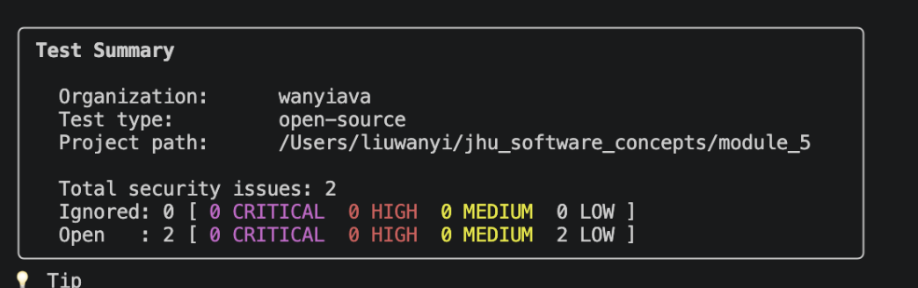
Besides, I turn on the snyk code and executed snyk code test to run static application security testing for my project. As shown in summary, my codebase is free of critical vulnerabilities. 